Team 15

Team Members:

* Ahmed Hossam Mohammed Sedky Sec:1 Bn:2
* Ahmed Mohammed Abd elftatah sec:1 Bn:5
* Ehab Wahba Abdelrahman sec:1 Bn:22
* Mo’men Maged Mohammed sec:2 Bn:11
* Mohanad Alaa Ragab sec:2 Bn:31

Emai to contact: [hossedky@gmail.com](mailto:hossedky@gmail.com)

1. Extract the unique features in all images using Harris operator and λ-.

* Results
* First image computation time = 0.5 sec

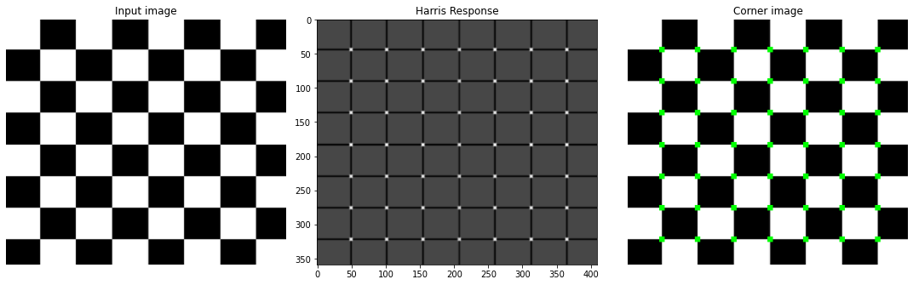

* Second Image computation time = 0.5 sec 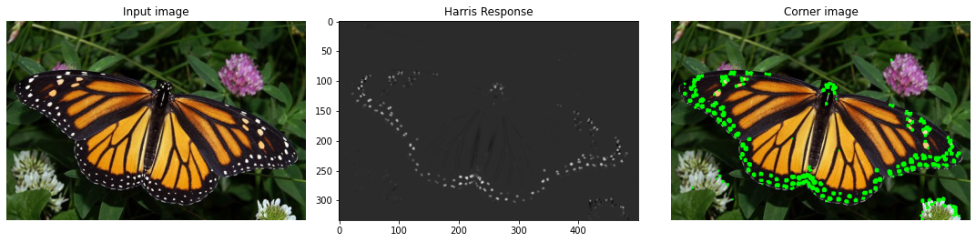
* Discussion

First, we compute the gradient of the image in x-direction and y-direction using Sobel.

Second, we compute the second derivative of x,y, and x with respect to y.

Then we apply a Gaussian filter to it.

Then we compute the determine and the trace of this matrix



Finally, compute harris response “R”

Where R = det - k \*(trace)^2

Where k: corner sharpness = 0.04

Get pixels above specific threshold and color it on the

original image